**Hands-on Documentation: SLF4J + Logback Logging**

**Title:**

Logging Error and Warning Messages Using SLF4J with Logback

**Objective:**

To demonstrate how to log different severity levels (error and warning) using **SLF4J (API)** with **Logback (implementation)**.

**Tools & Technologies Used:**

* IntelliJ IDEA
* Java 8+
* Maven
* SLF4J v1.7.30
* Logback v1.2.3

**Steps Performed:**

**Step 1: Added Dependencies**

<dependency>

<groupId>org.slf4j</groupId>

<artifactId>slf4j-api</artifactId>

<version>1.7.30</version>

</dependency>

<dependency>

<groupId>ch.qos.logback</groupId>

<artifactId>logback-classic</artifactId>

<version>1.2.3</version>

</dependency>

**Step 2: Created Java Class**

public class LoggingExample {

private static final Logger logger = LoggerFactory.getLogger(LoggingExample.class);

public static void main(String[] args) {

logger.error("This is an error message");

logger.warn("This is a warning message");

}

}

**Output:** 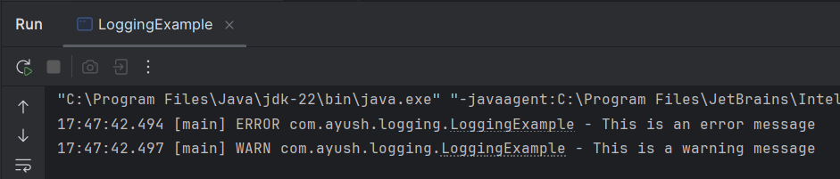

**Conclusion:**

* Demonstrated basic **logging in Java**.
* Learned to use **SLF4J API** with **Logback backend**.
* Logged messages with different **severity levels** like ERROR and WARN.